# PROJECT DEVELOPMENT PHASE

|  |  |
| --- | --- |
| **Team ID** | **PNT2022TMID47136** |
| **Team Members** | **Teamlead: Sudharshini V**  **Member2: Sharmila R**  **Member3: Nishanthini K**  **Member4: Tharani K** |
| **Project Name** | **Project – IOT-Based Safety Gadget for Child Safety Monitoring and Notification** |

**SPRINT-4**

# Project Diagrammatic Structure& Code:

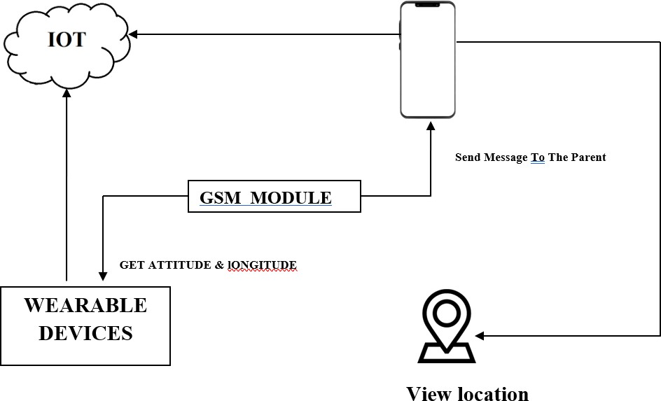

* Parent mobile and wearable devices are connected with the help of cloud.
* If child was lost , the parent can access the location of child through the mobile application with the help of GSM module.
* Then, we can view the location of child with the help of mobile application.

➢

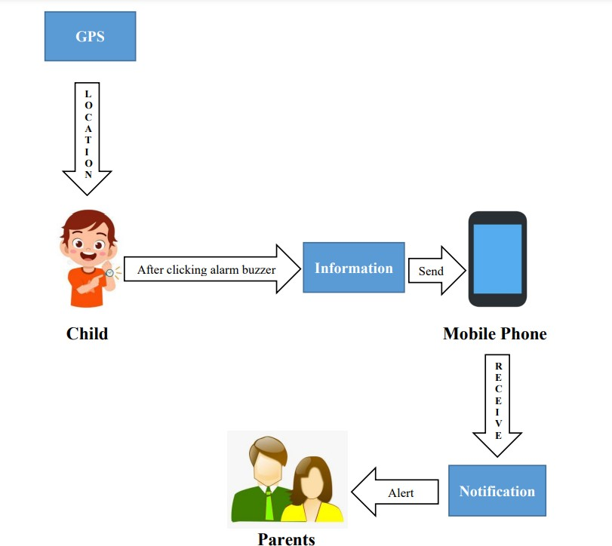

# CODE:

## #Source code for GPS Location:

import phonenumbers import opencage import folium

import webbrowser

number = "+916385571249"

from phonenumbers import geocoder # is a function par_number = phonenumbers.parse(number)

location = geocoder.description_for_number(par_number, "en") print(location)

# to see the service provider name from phonenumbers import carrier

service_par = phonenumbers.parse(number)

S_provider= carrier.name_for_number(service_par, "en") print(S_provider)

# opencage is for to view the location.

from opencage.geocoder import OpenCageGeocode key = "7098ec840cb24aa9a5c38cce49fb3b81" geocoder = OpenCageGeocode(key)

query = str(location)

result = geocoder.geocode(query) #print(result)

lat = result[0]['geometry']['lat']

lng = result[0]['geometry']['lng'] print(lat, lng)

####

mymap = folium.Map(location=[lat, lng], zoom_start=9) folium.Marker([lat, lng], popup=location).add_to(mymap) mymap.save("mylocation.html") webbrowser.open_new_tab("mylocation.html") **#Source code for Mobile Call:**

from twilio.rest import Client

account_SID = "AC89d677f42205372d8c7467d77f8124a5" auth_token = "8d60fae39b28beaed14514b8d1cbf812" client = Client(account_SID, auth_token)

call = client.calls.create(

from_='+12136932446', to='+918438106497',

url='https://handler.twilio.com/twiml/EH7fcba664228739cbc7d1e517 93d42420'

)

print(call.sid)

## #Source code for Notification (Alert Message):

from twilio.rest import Client

account_SID = "AC89d677f42205372d8c7467d77f8124a5" auth_token = "8d60fae39b28beaed14514b8d1cbf812" client = Client(account_SID, auth_token)

message = client.messages.create( from_ ='+12136932446',

to = '+918438106497',

body='Hi from Twilio'

)

print(message.sid)

## OUTPUT:

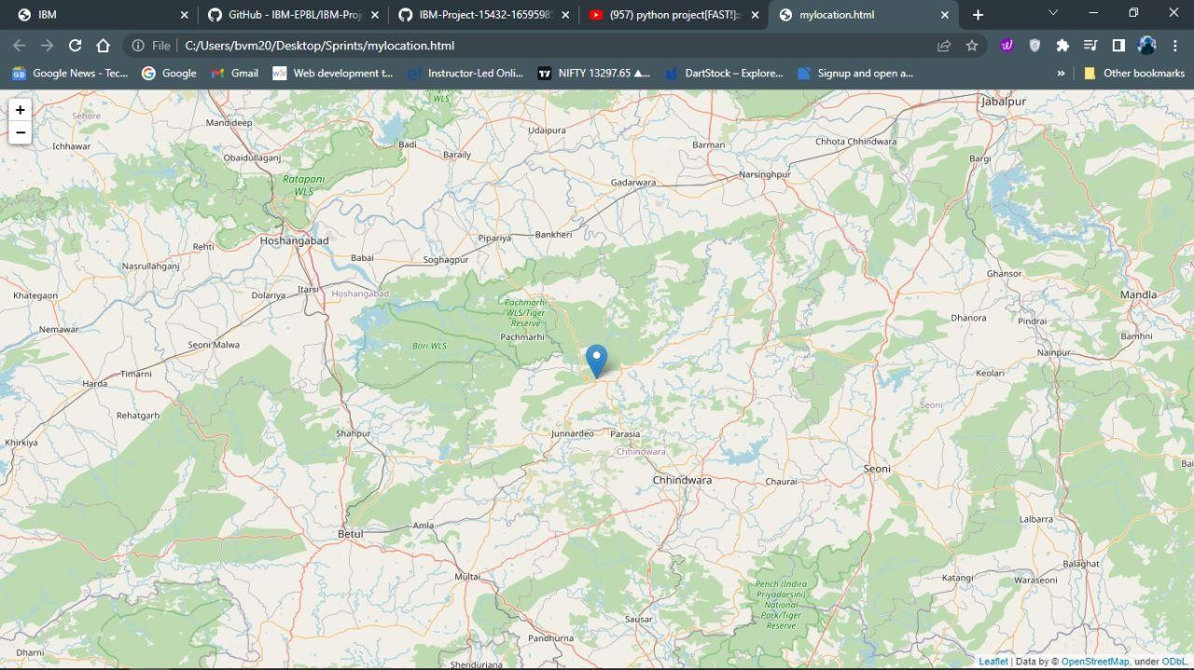

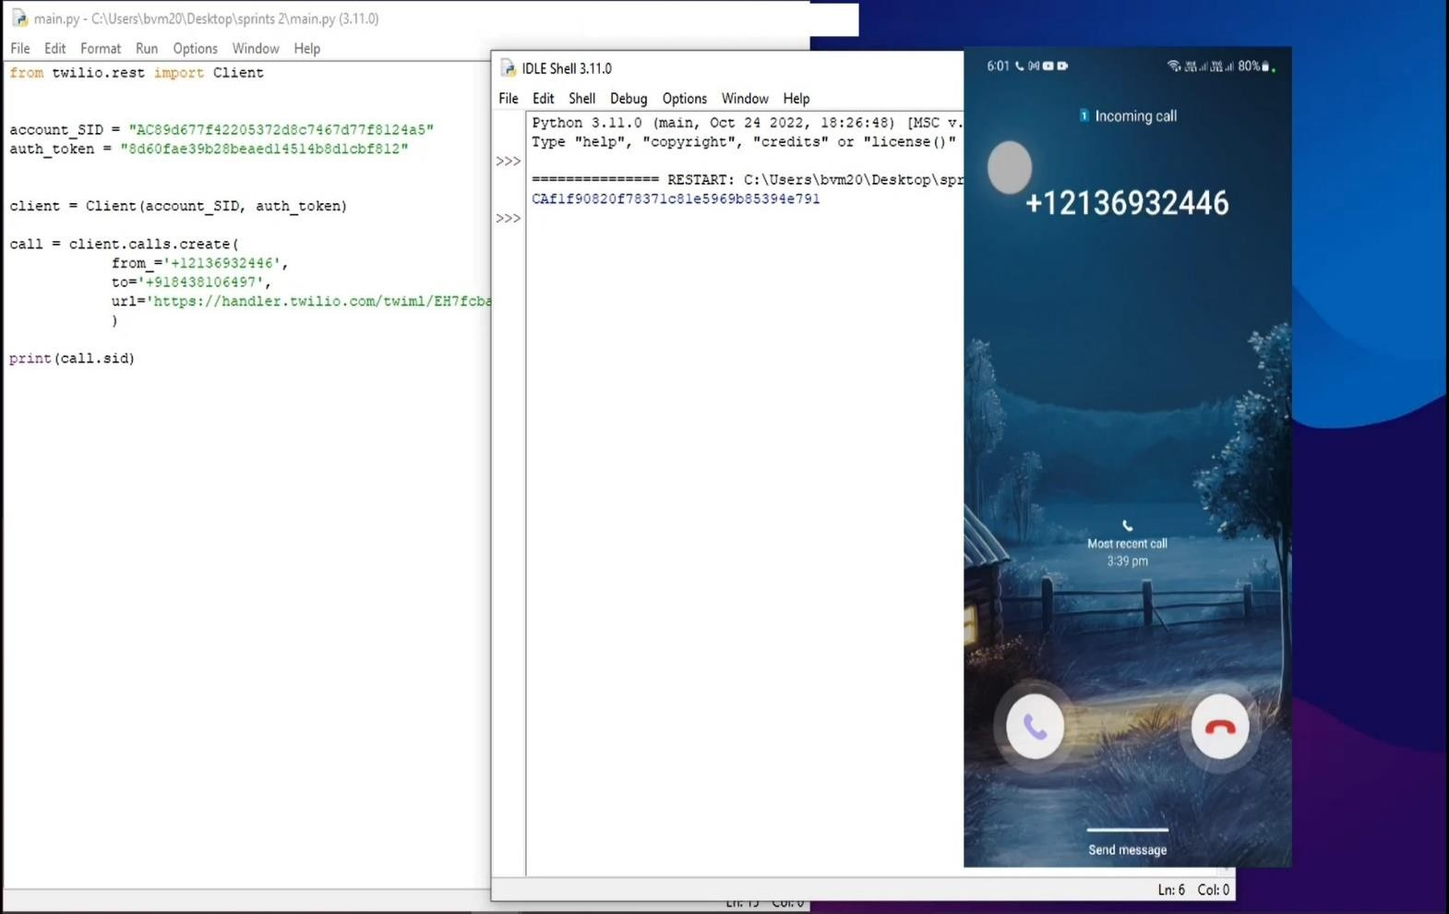

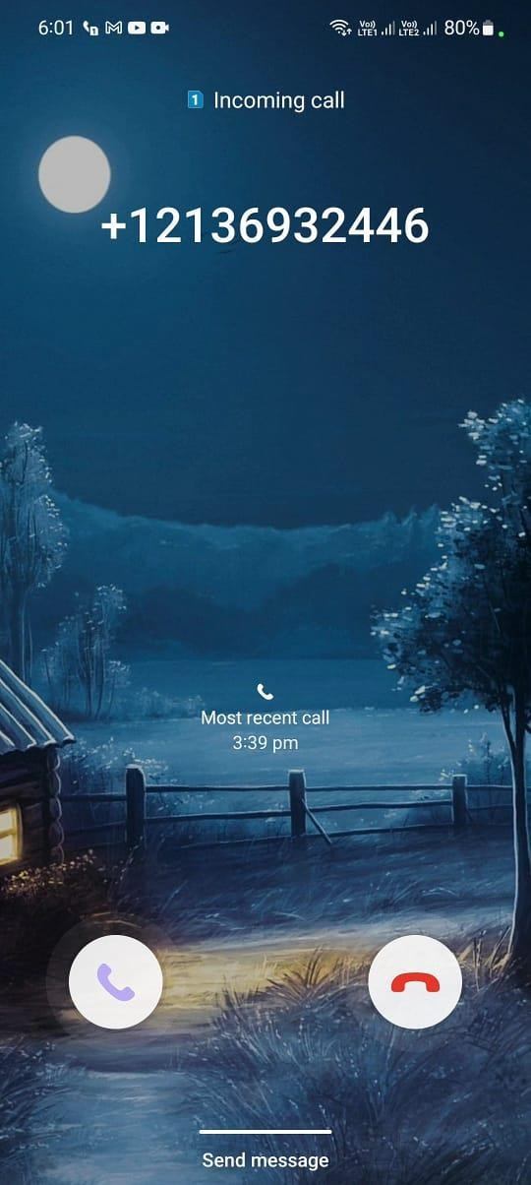

Alert Message from your Child



